Construction Steel Pencil: BauStahl Classic

We drill out a real construction steel and provided it with a clutch pencil mechanism.
By its relatively heavy weight of approx. 80 gram this exclusive crayon lies perfectly in your hands when you are drawing. When outlining the movement is to come loosely from the wrist, our construction steel pencil supports ergonomically the correct movement.

For architects or engineers it is additionally extremely delightful to hold in hand during first drawings,the material with which they later realize their buildings,

We pack our construction steel pencil into a tube from fibrated concrete, by this means the construction steel comes back to where it belongs: to the concrete.
Typically this fibrated concrete tube is used as a spacer to fix the formwork in concrete structures.

As you see our Construction Steel Pencil BauStahl Classic is the perfect promotional gift for all those who are working at the building side.

This pen was awarded with an acknowledgment by German Steel Innovation Prize and it is the winner of Promotional Gift Award 2009.
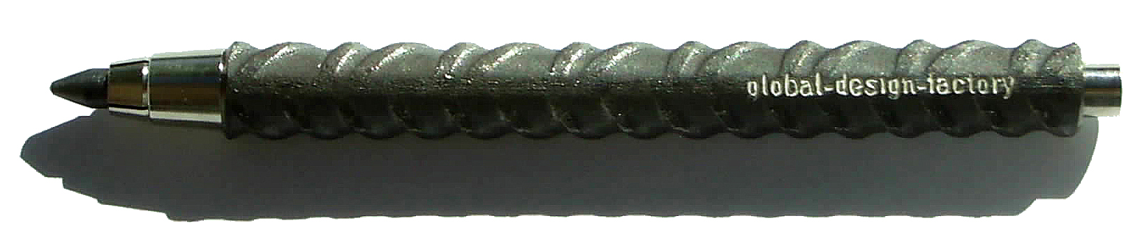
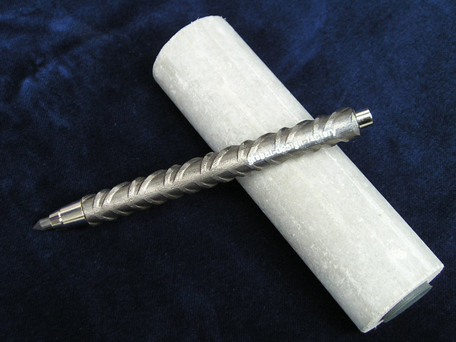
Clutch pencil with 5,6 mm lead.
For drawing, marking and writing.
12 mm construction steel.
Ergonomically meaningful weight of ca. 80 grams (2,8 oz.)
Length ca. 140 mm ( 5,51 in.)
Packed in fibre cement tube.
Maxi ballpen refill optional available.
Laser engraving possible.


